**Probability and Statistics - IT2120**

**Ranaweera K.R**

**IT24103826**

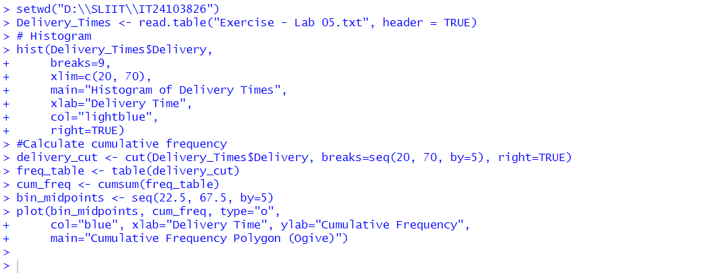

**3.** The histogram in Figure 2 shows the distribution of delivery times.

* The shape appears to be **slightly right-skewed (positively skewed)**.
* Most of the frequencies are concentrated around the **40–50** range.
* There are **fewer observations** in the higher delivery times (60–70), which creates a tail extending to the right.

